**PRACTICAL NO: 4**

**Aim:-**Configure DHCP server and client for DHCP service.

**TOPOLOGY:**

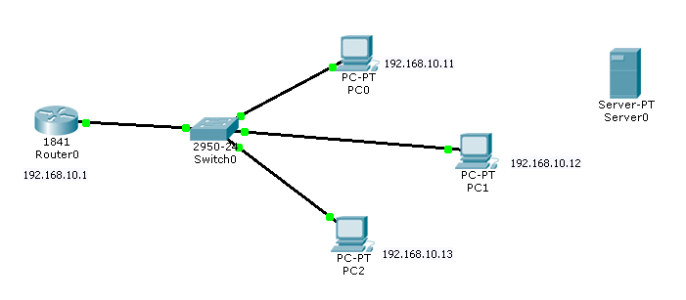

**Router Configuration:-**

**1) Assigning IP address:-**

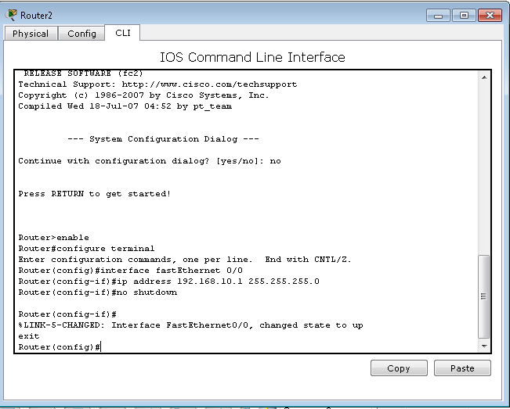

**2) Defining Range of IP addresses:**

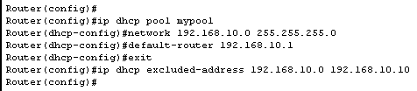

**Conclusion: -** We learnt to configure DHCP server and client for DHCP service as shown above.